Report on Summer camp for Night School children
April 29th to May 4th 2019, Jawadhi Hills
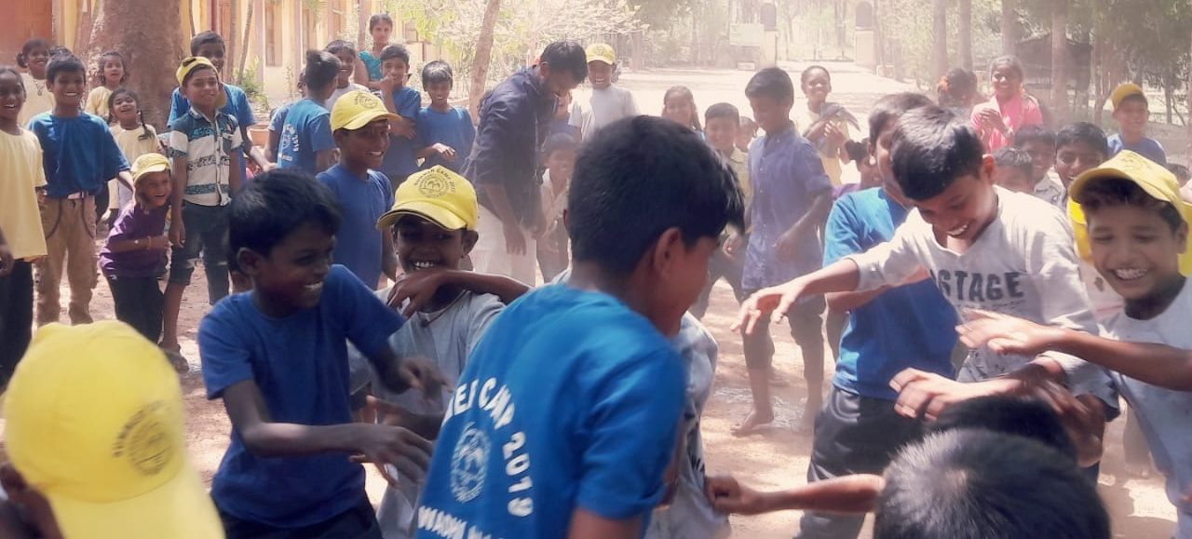
The summer camps for the children enrolled in the Evening study centers run by Community Health Department CMC, and Don Bosco Tribal development center were held from 29th April to 4th May . 780 children enrolled in the camps, and the camps were conducted by 64 teachers and supervisors and additional faculty for specific activities. As in the previous years the children gathered in 6 locations based on ease of geographic access. The day started with assembly and attendance at 9am and finished with attendance and dispersal at 3:30 pm. The children were accompanied to the camp and on their return home by the teachers. They had refreshments in the morning and evening and lunch at the camp. The food for the children was prepared on site based on last year’s feedback and the menu was decided based on locally available fruits and vegetables. The activities and trainers were selected based on the objectives of empowering children as leaders for the next generation while making it as enjoyable as possible.
This year we had more indoor activities to protect the children from the extreme heat we are experiencing this summer. We had to repeatedly request the children to use water carefully and many children brought water bottles from home.
The Community Health Department and Don Bosco Tribal Development Society would like to thank the FOV Germany, the Vellore Foundation, Sweden, and all the other FOV’s for their support of this activity, for the encouragement, prayers, ideas and suggestions and the funds. We also thank the Child Health 3 department, Wellcome, Department of Opthalmology, Rehab, and LCECU for staff to run the camps.
Please find below a report on the activities in this years camps:
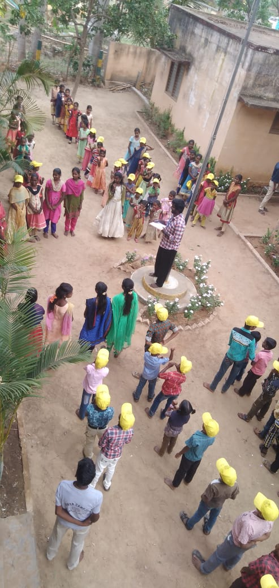
1. Morning assembly and attendance: Every day the camp started with an assembly and flag hoisting followed by attendance. The privilege of flag hoisting was given to the best team of the previous day. In each camp the children were divided into 4 teams for the sake of competitions, maintaining discipline, camp hygiene etc and points were granted to each team. There was attendance at the end of day also, and this helped us make sure each child returned home safely.
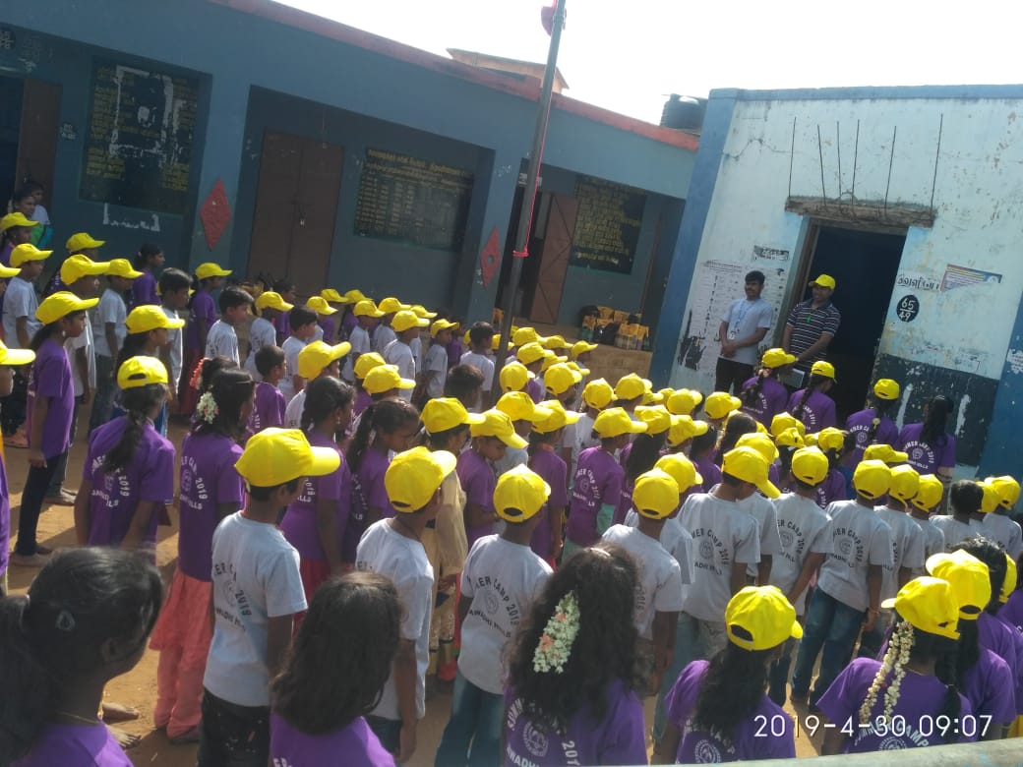

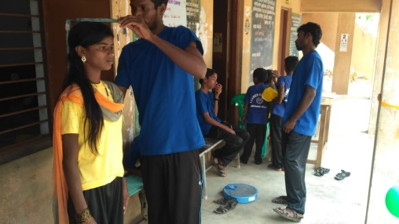
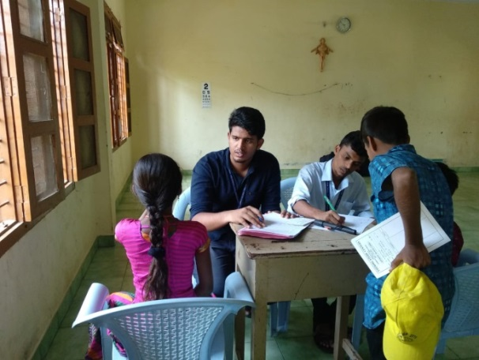
2. Medical check up: As in the previous years, each child had a medical check-up during the camp. This consisted of a recording of height and weight to monitor growth, tests for refractive errors and eye pathology, an examination by a doctor for dental conditions, skin diseases, screening for heart disease, and other systemic examination. Children who needed further evaluation were referred to CHAD or CMC. This year there was an out break of chicken pox and so some of the children registered for the camps could not attend. We had to send away 5 children so others did not get infected. The medical team consisted of doctors from CHAD and Child health dept 3, optometrists, nurses and a social worker. All children were given a health card also.
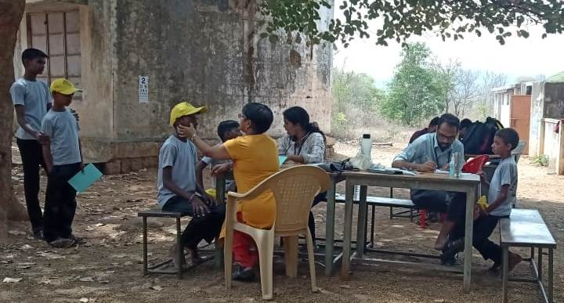
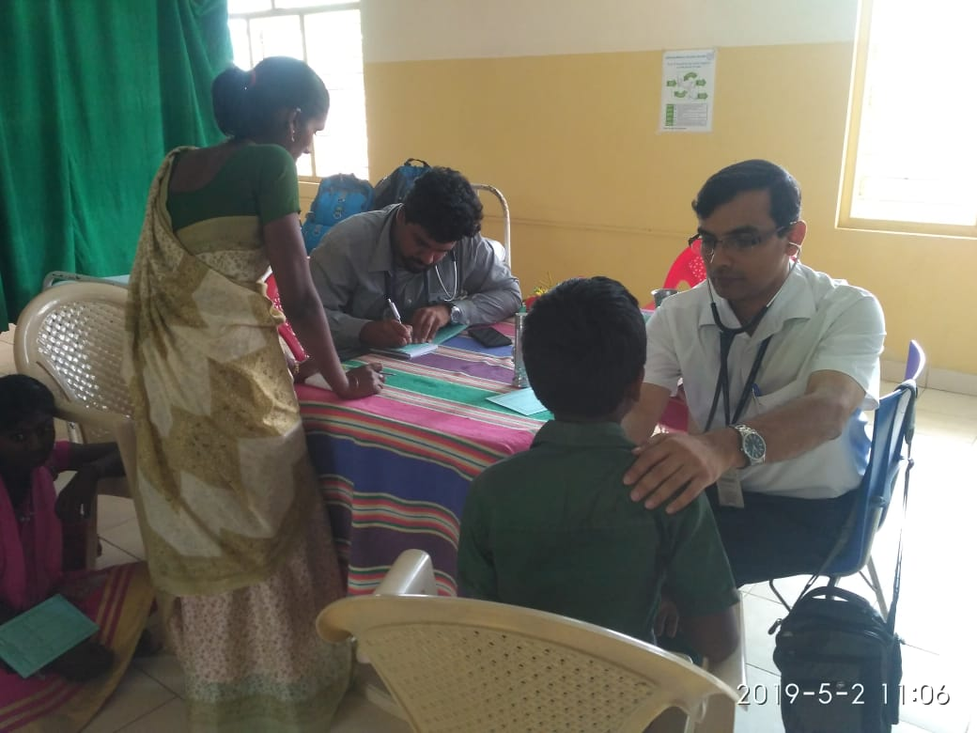

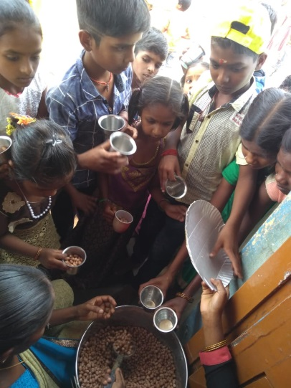
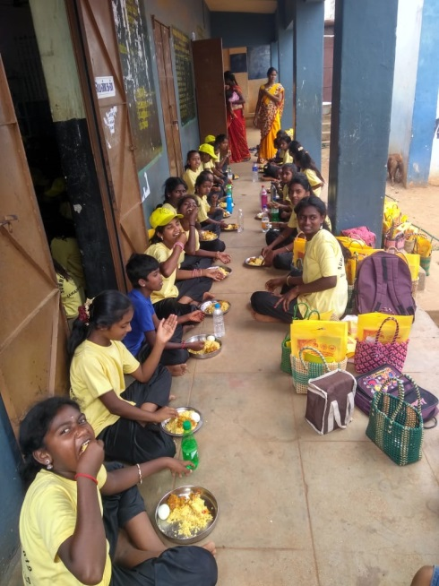
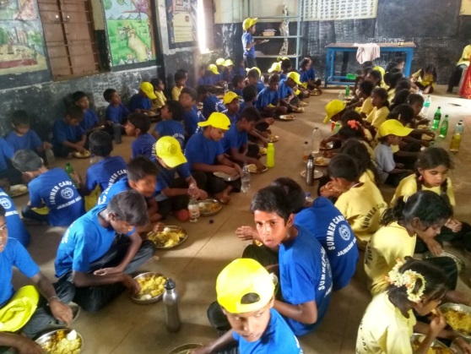
3. Refreshments: Every day the children had a mid morning snack, lunch and an evening snack in the camp. We have made use of only locally available fruits, vegetables and snacks. Each days lunch had a fruit and vegetable in addition to either chicken or egg, and rice. We emphasized the importance of eating a healthy meal and not wasting food. The snacks were also local foods such as horse gram, millet biscuits, groundnuts, peas etc. On the last day the children had chicken biryani and this was something the children really enjoyed.

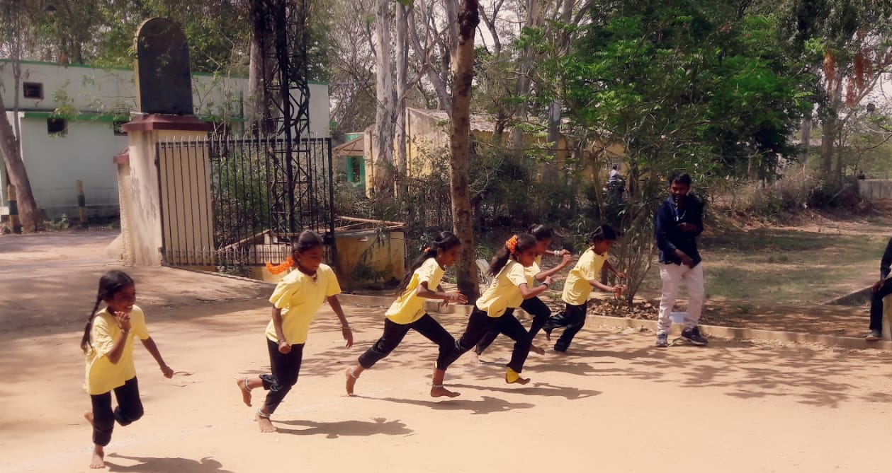
4. Games: Every day the children had some time for outdoor games. This was a great opportunity for children from different villages to get to know each other. The games were competitive and teams competed with each other to gain points. The winners were given a prizeand the priviledge of hoisting the flag the next day in assembly.

4. Folk arts: A folk arts team from Chennai spent several sessions in each camp site. The children earnt 3 traditional dances:
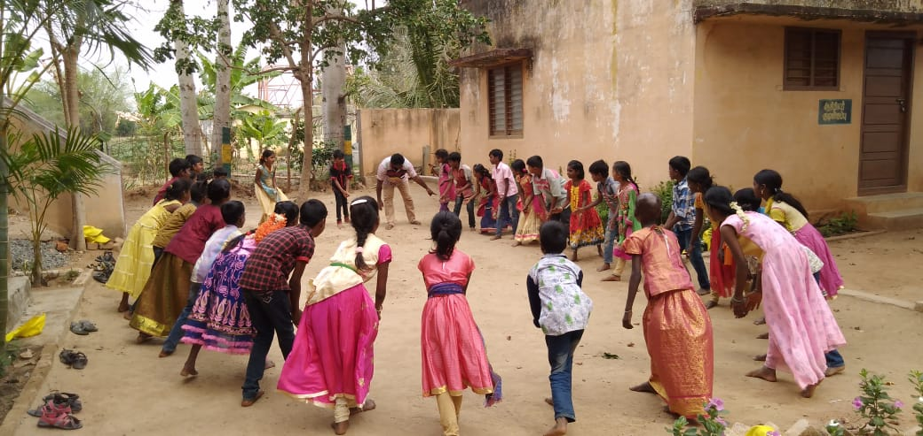
a. Kummi- a folk dance popular in tamil nadu and kerala, with simple steps usually accompanied by rythemic clapping.This is an ancient dance form when there were no instruments to keep time and participants clapped their hands to keep time. The steps usually imitate various harvest activities such as cutting crops.

b. Kollatam: a dance performed by women usually, holding 2 sticks which are beaten to make a rhythmic sound
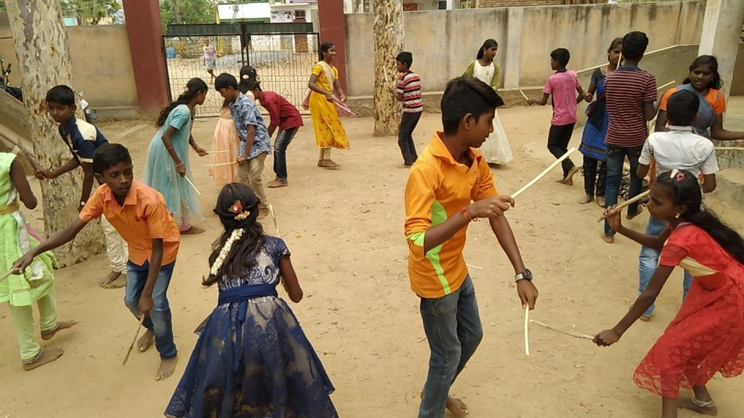

c. Oyilattam: this is a folk dance performed with handkerchiefs tied to the fingers. Its origins are from southern Tamilnadu and depicts scenes from the epics.
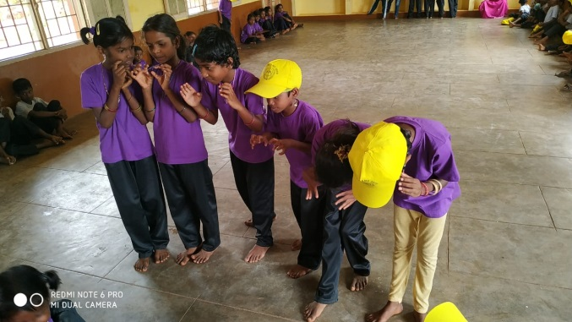
5. Street theater: This year we included street theater as one of the programs for the summer camp. We have planned to conduct regular health educations for the 50 villages where there are night schools. These programs will focus of delivering one important health message per program, with 10 programs planned for a year. They will be delivered by the children to the elders in their own village through street theater, debates and skits. The children had the opportunity to be trained by a team from Chennai. We will try to organize one more training for them after a few months.
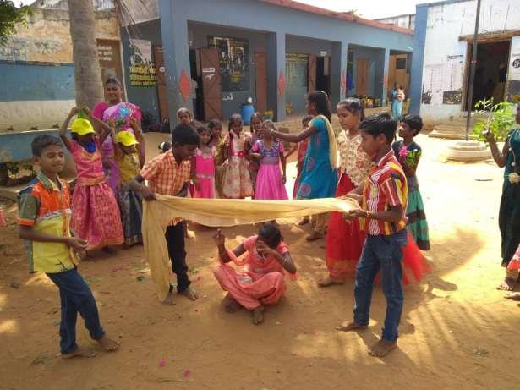

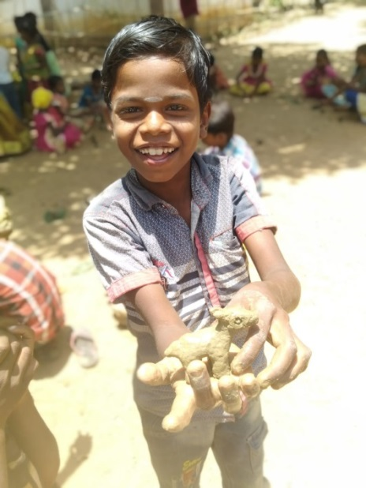
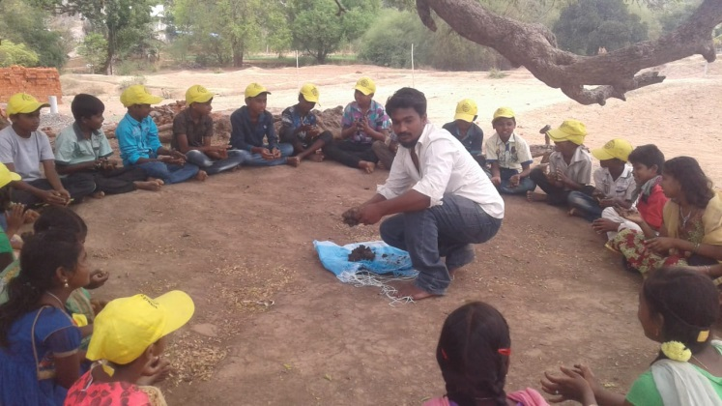
6. Clay modelling: One of the most popular activities this summer camp was making toys from clay. The trainer is Mr. Rajesh, who has graduated from a fine arts course and is versatile in many forms of arts. The clay for the children was taken from the local lakes. The children were very enthusiastic and outdid themselves making a variety of toys from animals to crockery to toy phones! The girls generally made vessels and human figurines, while the boys made animals, phones cars and so on. Some children were very skilled and made exquisite figurines. We will set up an oven to bake these toys, and the trainer is willing to do some more sessions for interested children.
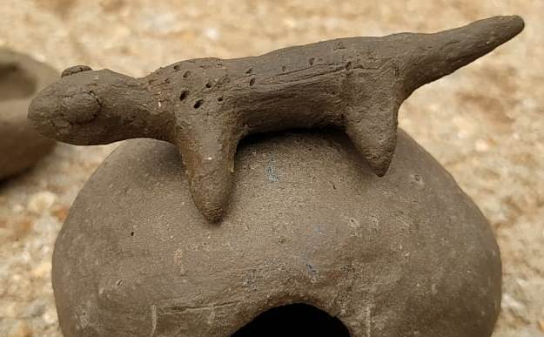
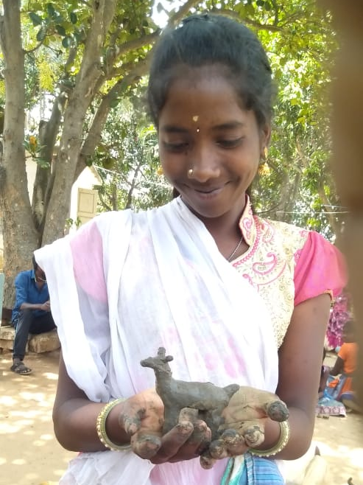
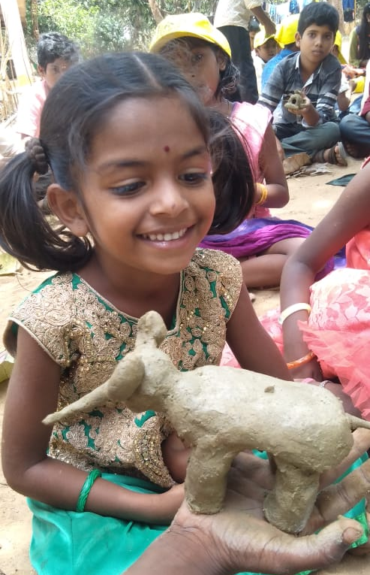

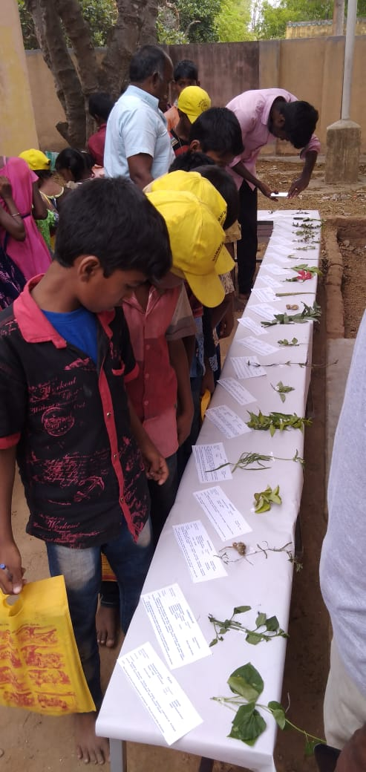
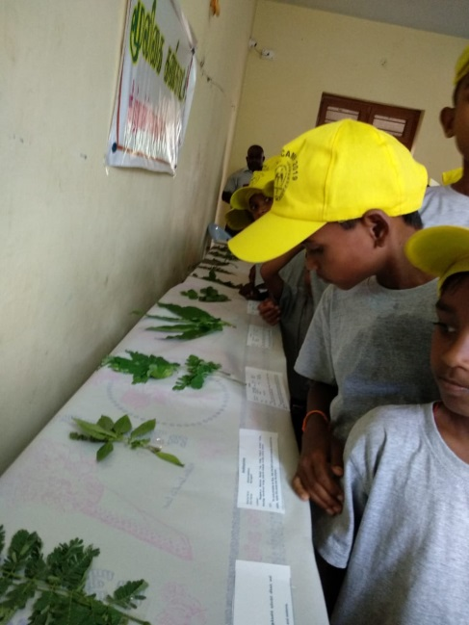
7. Siddha and herbs: The siddha team taught the children how to identify and use 10 forest herbs. This is the third year they are involved in the camps, and every year they teach 10 new herbs and organize an exhibition of common herbs.

8. Child rights: A staff member from the Don Bosco Social Action and Research addressed each camp site and taught the children about children rights in India. He introduced the children to some of the schemes and provisions made by the government for children in the area of education, prevention of exploitation for labour and the various child protection agencies. The children were taught about “Good touch and Bad Touch” and informed about the prevention of child sexual abuse act.
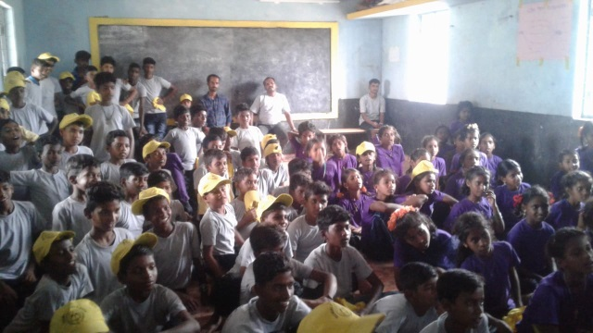
9. Magic: A session which excites the children greatly is the visit by the magician. The person who runs this session also regularly visits sick children in the oncology ward in CMC during the Christmas program. He teaches the children some tricks before he finishes his program and the children enjoy this show.

10. Basic first aid: the children learnt basis first aid techniques to follow for minor injuries, fractures, drowning and insect bites. They had demonstrations on making and using splints and the importance of calling for help soon.

11. Road safety: An important cause of adolescent morbidity and mortality in Jawadhi is road traffic incidents. Each year we have a session with the children on road safety. The main messages are about underage bike riding, drinking and riding/ driving, traffic signals, importance of helmets and protective devises, pavilion riders and the dangers on f=travelling 4 to 5 per bike, and over crowded autos.
12. Life skills education: Life skills education is conducted by the social workers from CHAD and focusses on two areas. Career guidance and on life skills such as dealing with disappointments, having goals in life, relationships with opposite gender, coping with academic stress, physiological changes in adolescence etc. It was conducted for the older children and separately for boys and girls. As in the previous years the children had a lot of questions and we were able to correct some misinformation they had on physiologic changes and sex.
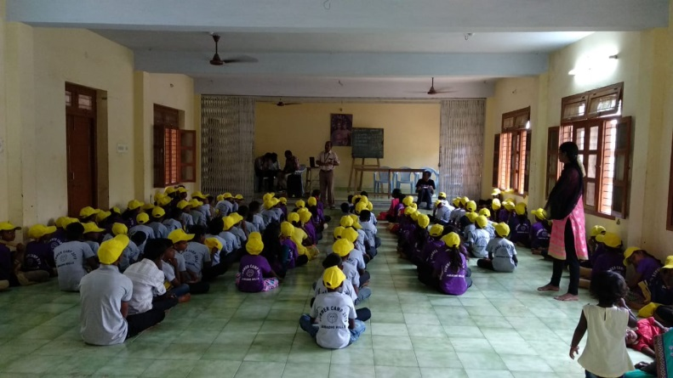
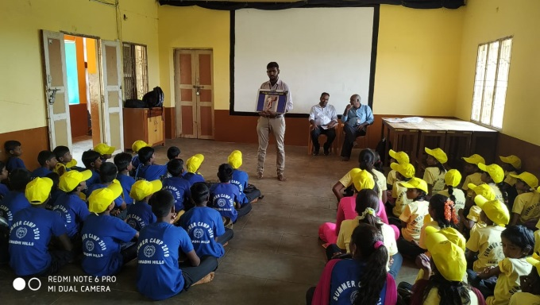

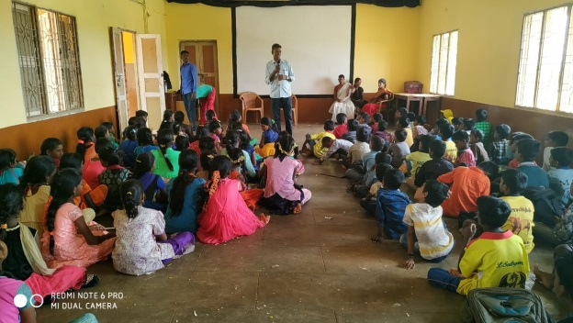
13. Substance abuse: Every year one of the Substance abuse program field workers, Mr. Mani, addresses the children on the dangers of alcohol use. This year also Mr. Mani engages the children with songs and stories on the effects of alcohol consumption on family society, childrens education and health. He emphasized the importance of staying away from alcohol and smoking and informed the children on avenues to seek help for family members who need help to stop drinking.

14. Gifts: In the last few years we noticed that some children come to the camp with torn clothes. It affects the morale of the child, especially when they are being photographed. This year we deided to give each child 2 T shirts and a pair of pants and a cap. The children were very happy. We spent 2 months measuring the children in each center to ensure that each child got clothes that fit, and the night school teachers helped a lot with this. The children were very happy to have T shirts with the CMC emblem and wore them proudly to the camp on almost all days. The clothes were purchased from Tirupur where most of the Knitwear companies are and were got at a subsidized rate as they were for the camps and the owner was known to Fr. Vinodh. The boys had blue and grey T shirts, the girls yellow and purple. All pants were black and all caps were yellow.
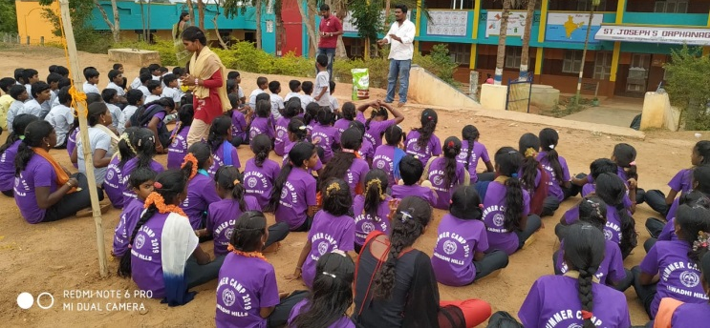

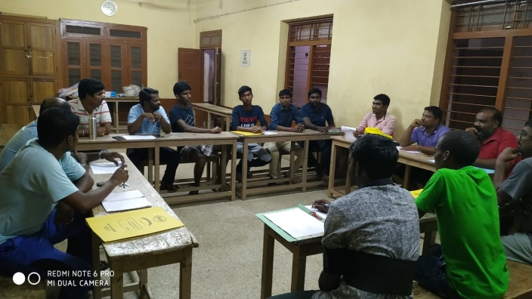
15. Review meetings: Every evening we had a review meeting involving the CMC and Don Bosco organisers and the various trainers. A report was read out by each camp site organizer on the activities of the day, including the positives and the problems. All problems were reported and discussed. There were small minor injuries from falling down, problems due to water shortage and teachers taking leave. But no major problems were encountered. The trainers gave a lot of valuable feed back on improvements for next year.

Some more pictures….
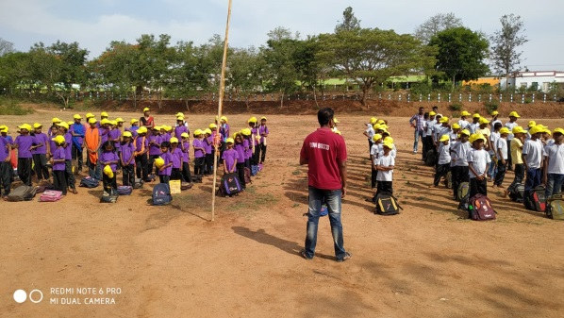
Morning assembly and attendance

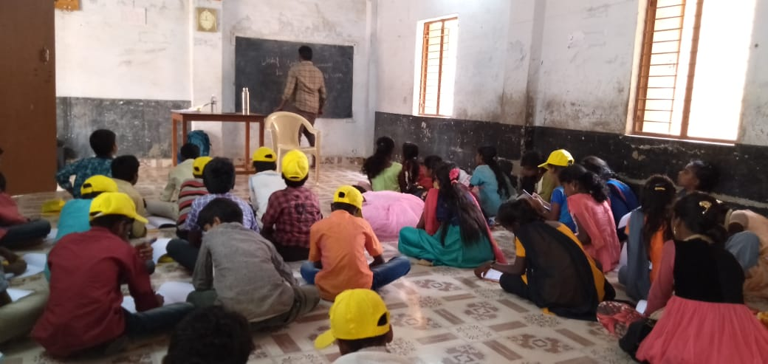
Some time for formal teaching

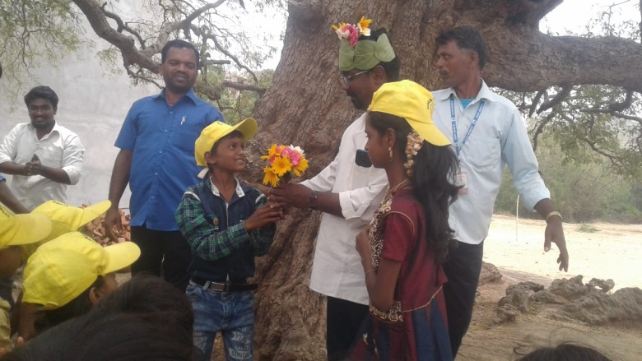

Children welcoming Fr. Vinodh to the camp

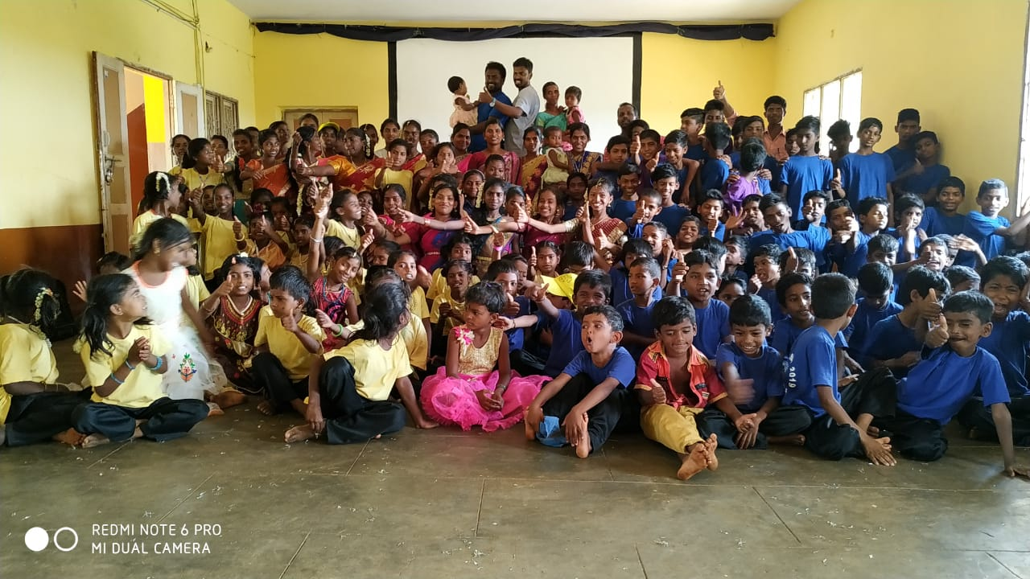
Athipet zone group photo

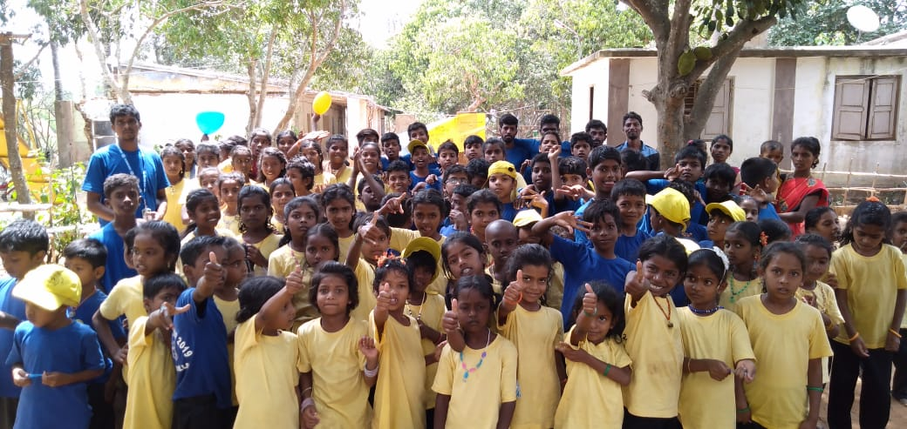
Koviloor zone group photo

Veerapanur zone group photo

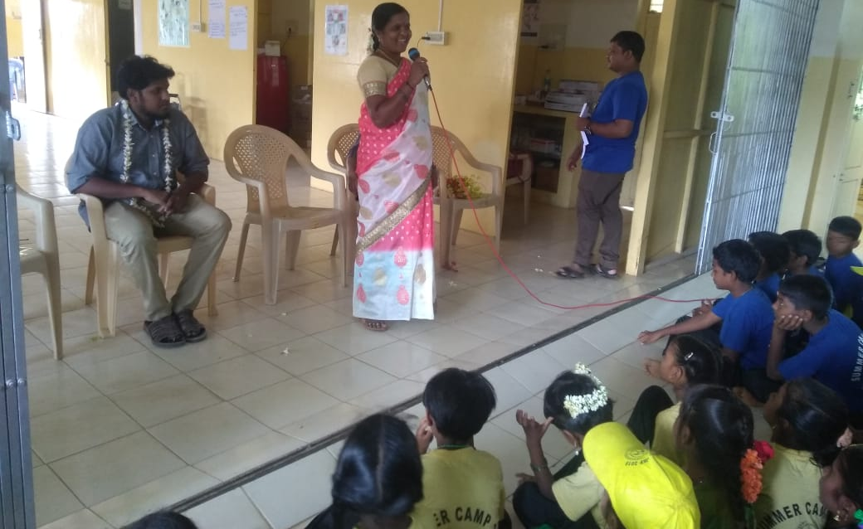
Veerapanur Panchayat President
addressing the children

